Haorui Chen - 10407315 – cwk4 - SIFT

3

When T goes from 0 to 5, number of matched keypoint pairs grow rapidly, then the number remain unchanged when we further increase T.

4

4.1 How the choice of parameters aﬀect the key points found by SIFT algorithm?

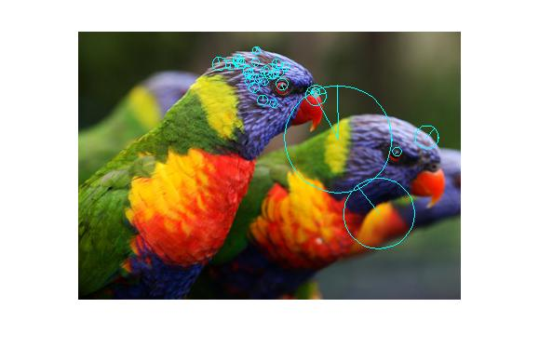

4-1 octave=4, interval=5, contrast_th=0.03, edge_th=10

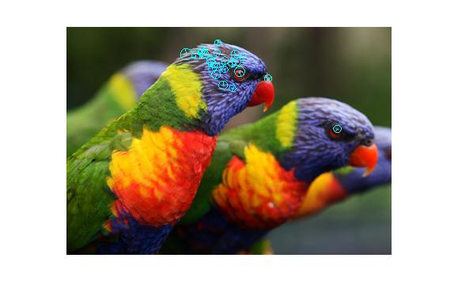

4-2 octave=1, interval=5, contrast_th=0.03, edge_th=10

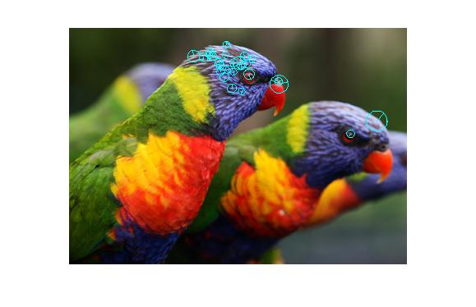

4-3 octave=2, interval=5, contrast_th=0.03, edge_th=10



4-4 octave=7, interval=5, contrast_th=0.03, edge_th=10

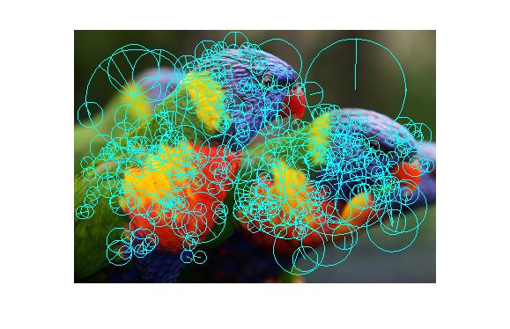

4-5 octave=4, interval=1, contrast_th=0.03, edge_th=10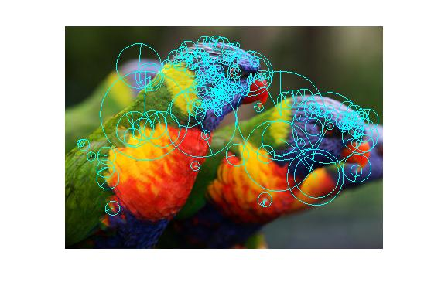

4-6 octave=4, interval=3, contrast_th=0.03, edge_th=10

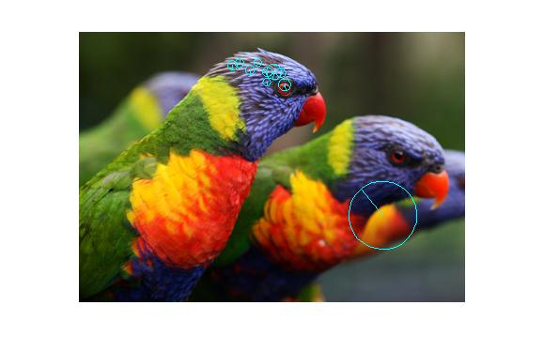

4-7 octave=4, interval=7, contrast_th=0.03, edge_th=10

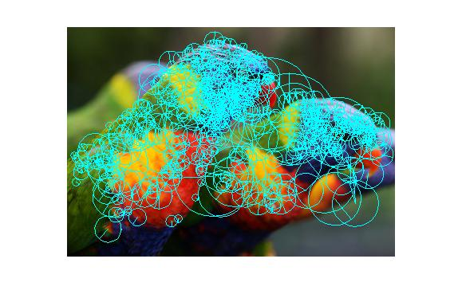

4-8 octave=4, interval=5, contrast_th=0.01, edge_th=10

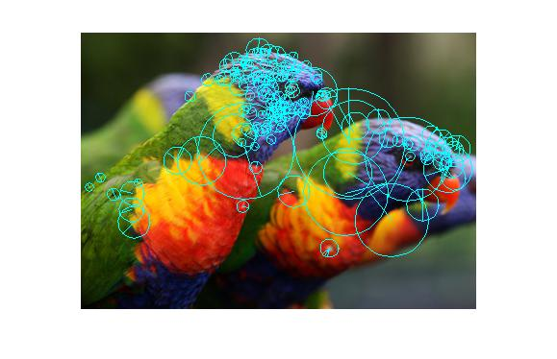

4-8 octave=4, interval=5, contrast_th=0.02, edge_th=10

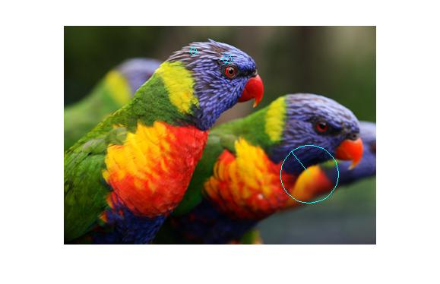

4-8 octave=4, interval=5, contrast_th=0.04, edge_th=10

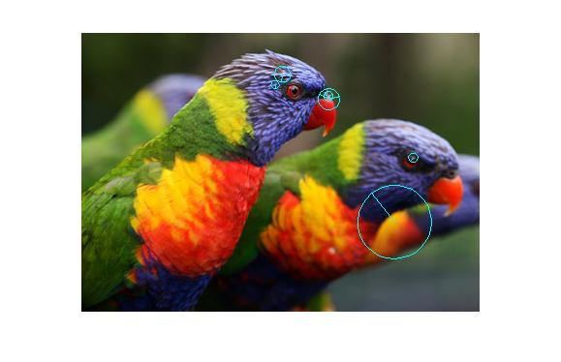

4-9 octave=4, interval=5, contrast_th=0.04, edge_th=4

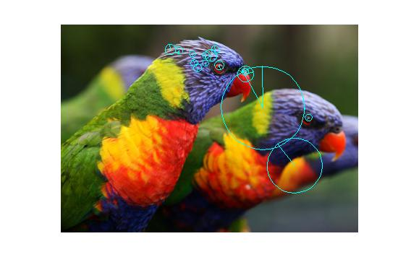

4-10 octave=4, interval=5, contrast_th=0.04, edge_th=6

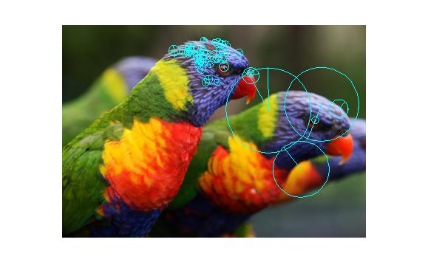

4-11 octave=4, interval=5, contrast_th=0.04, edge_th=20

Octave: When the number is small, increasing it will also increase number of key points; but when it get large enough, further increasing it will have no influence towards the number. Because when the image is not yet blurred to nothing remain, adding height of pyramid can still get more maximum detected.

Interval: Increasing its value will decrease number of key points.

contrast threshold: Increasing its value will decrease number of key points, as more points will be filtered out.

edge threshold: Increasing its value will increase number of key points, yet there is a value that further increase over it will give no more change in number of key points.

4.2

Parameters I chose is octave=4, interval=5, contrast threshold=0.03, edge threshold=10.

Less number of octaves cannot get us fully observe features at different scale, yet too large the number will cause nothing remains in the images in extra octaves are actually of no use.

Smaller number of intervals indeed add features, yet many of them will describe similar or even same context. In the meanwhile, too large an interval cannot get features discovered reasonably fully.

Smaller threshold cannot be able to filter out features which have low contrast, thus being vulnerable to noises; larger threshold filters out too much and left virtually no key points.

Smaller value of edge threshold is too strict, thus produce features that cannot reasonably describe the image; larger value has little effect on filtering out edge responses.

4.3



4.12 0°

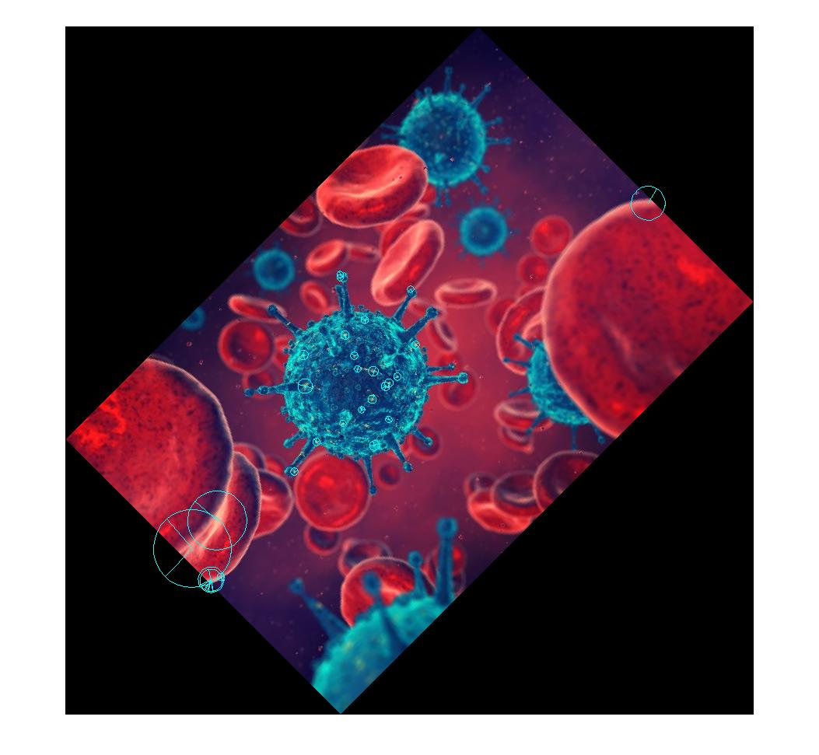

4.13 45°



4.14 90°

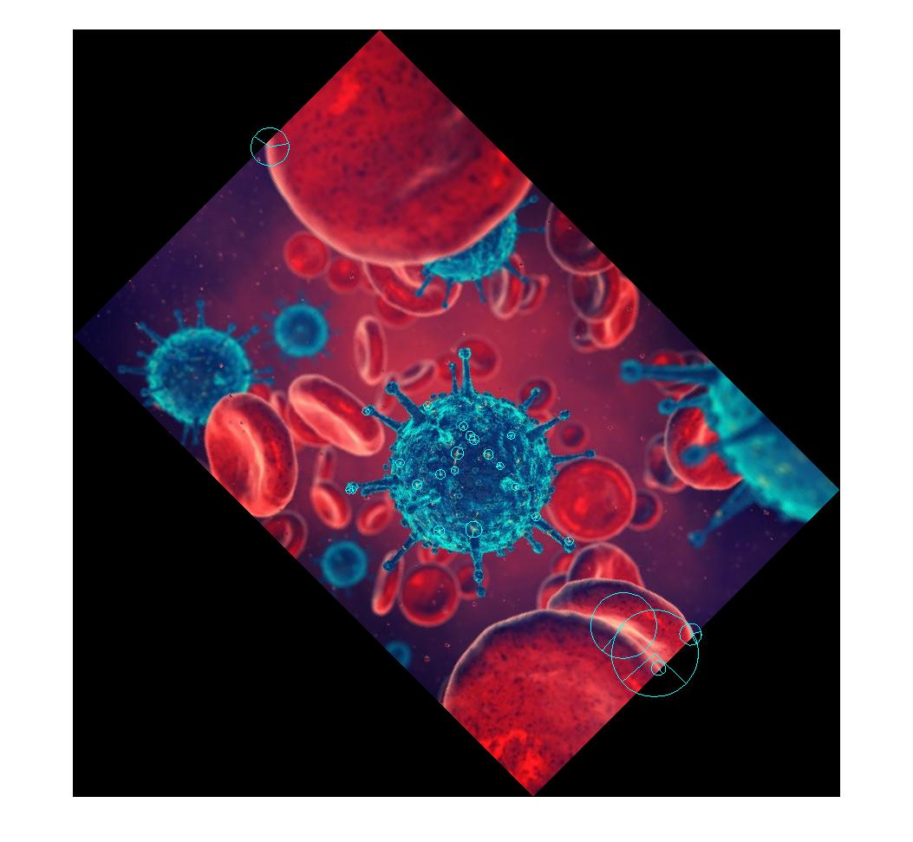

4.15 135°



4.16 180°

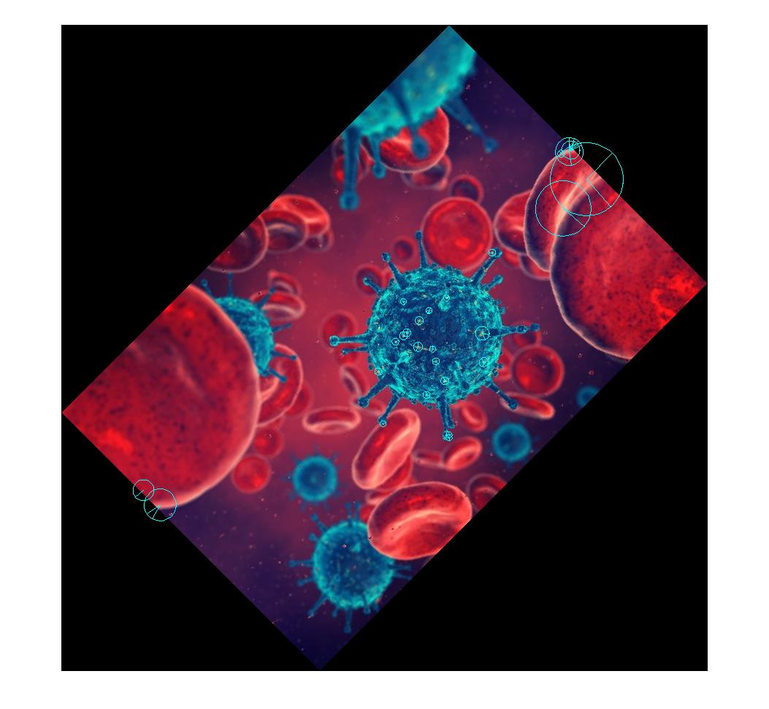

4.17 225°



4.18 270°

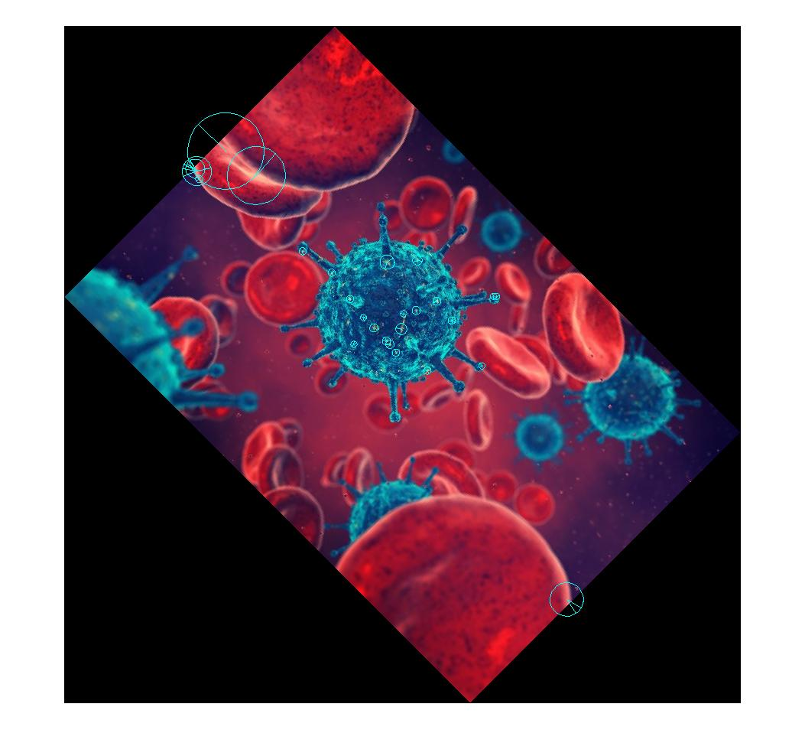

4.19 315°

Observation: many matches corresponding key points can be found throughout the rotation, although some detected keypoints only appears in one rotated image or several rotations.